Volcanism and earthquake:
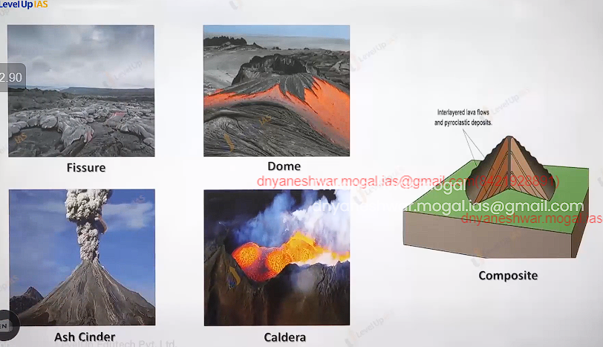

Intrusive volcanic landform:
- Cooling of magma can acquire various shape horizontal to vertical etc.

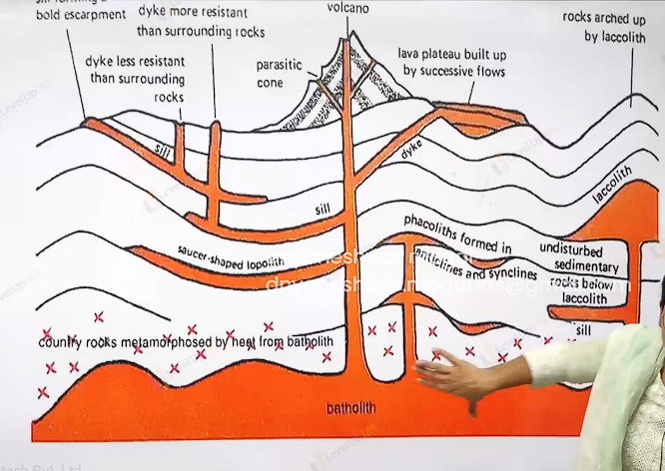
Batholic the cooling of magma chamber these are granitic body they are appeared on the surface denudation process removed overlaying material. Shield refers to expose bathetic.
Laccolith these are large dome shape bodies connected by the pipe like conduit from below it resembles the shape of mushroomed. Lopolith is saucer shape cooling of magma.
Sill : horizontal shaped bodies thinner one’s are sheet and thicker sill.
Dyke: its vertical shape pipelike structure.

Process shaping the landform:
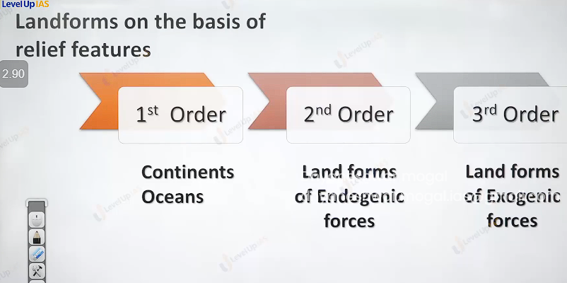

Landform on the basis of relief feature:
1st order relief feature
2nd order relief feature: land form because of these endogenic forces. Like volcanic land form, fold mountains block and faults. Rift valleys.
3rd order relief feature: these are landform which are formed because of exogenic forces
Ex. Landform formed by glaciers river and wind.
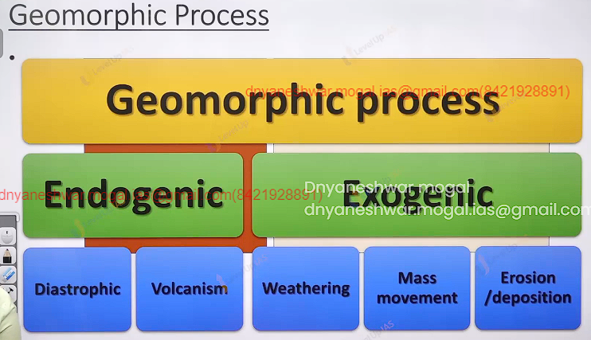
Geomorphic process: geo means earth and morphic shape therefore geomorphic process refers the process that have been shapes earth. It can be two type endogenic and exogenic.
There are two types of endogenic Diastrophic / catastrophic.
Diastrophic ex Plate tectonic theory.
Catastrophic: ex volcanism and earthquake

Endogenic process: these refers internal forces as they are powered by earths interior energy is generated in earth interior by radioactivity and residual heat. These forces are called as land building forces as they help in elevation and building of earth crust. They are two types slow building and fast building. Slow building is called as diastrophic forces it includes orogenic forces. Mountain building forces and include epeirogeny forces continent building forces.

Catastrophic refers to fast process that shape earth ex volcanism and earthquake.
- The external forces which are induced by sunlight are called as exogenic forces. Evens out (reduces) the variation on the surface of earth.
- Therefore called land wearing forces. Any exogenic element of nature like water ice wind wave capable of transporting earths material is called geomorphic agent. These geomorphic agent becomes active due to the difference in the slope.
- They try to erode material from the top slope, transport it over the slope and deposited them at lower level therefore they are derived their energy form the gradient. ( all exogenic process are covered under general term denudation.)

Denudation process/forces:
- Type
1) weathering: weather refers to disintegration of the rock into fragments it involves little or no movement material i.e. inceto movement
  - Chemical weathering
  - Physical weathering
  - Biological weathering.

There are 3 type denudations:
- Physical weathering: involves expansion forces due to temperature changes it can be also because of expansion water to ice and vice versa. Over burden pressure or load.
- chemical weathering: the breaking of rock due chemical it include the solution hydration oxidation and reduction.
- Biological weathering: it refers to breaking of rock due to biological organism earthworm and tree.
- Special landform: by physical weather is onion peeling r exfoliation
- Mass movement it refers to transfer of rock debris from the slope under the direct influence of gravity it ranges from slow movement to very fast movement it can affect shallow to deep columns.
- Weathering is not prerequisite for mass movement no agent like running water, glacier, wind and wave participate in process of mass movement.
- Example of mass movement creep, flow, fall, slump (contains rotation layer by layer) .
- Creep : it slow movement of the land hardly perceptible it occurred in moderately steep slope, forested slope.
- Electric post may occurred to be bent because creep effect.
- Flow movement : earth flow mud flow, avalanche it is rapid movement generally associated with saturated water later in the absent of vegetation avalanche refers movement of slope.
- Fall movement: exception it will not contain water saturation.
- Water fall, snow fall.

- Solifluction: it refers to downslope movement water saturated soil it can cause the subsidence of building around it solifluction can also have slow movement of soil it is generally seen in place where ground water is occupied in between permanently frozen soil. Movement involved in land slide is of dry material. Ex rock slide debruise side, slump.
- Slump : it form of land slide in which many units of debris slide backwards in relation to slope over which movement occurred.
- .
- . 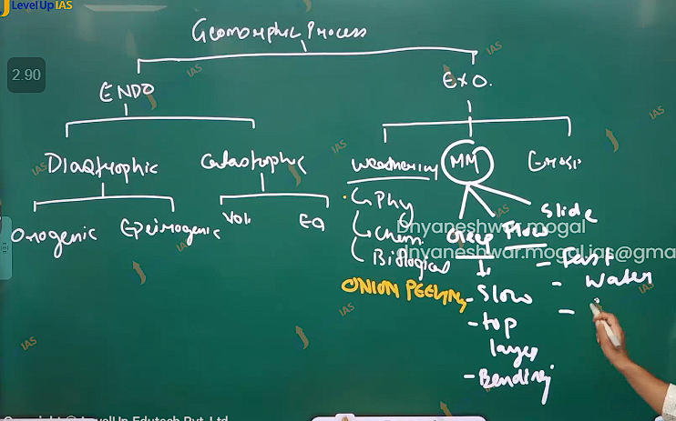
- .
- Erosion /deposition: erosion is process rock debris are collected and transported by geomorphic agent like wind wave river glacier. Weathering enhances erosion although it is not prerequisite for erosion. Deposition fallow erosion on moderate slope the geomorphic agent loss their velocity and energy. And therefore material they carry begin to settle.
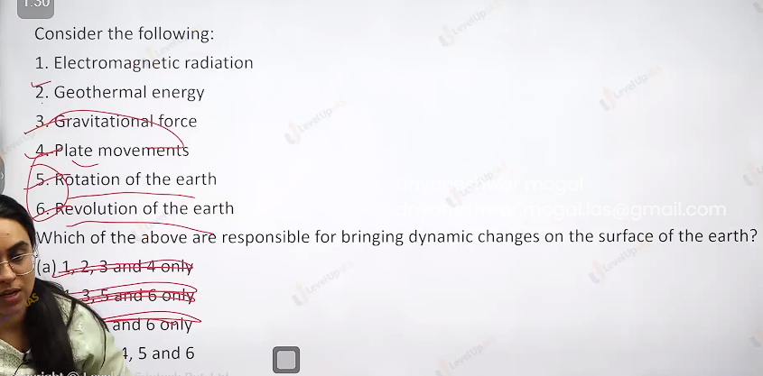

Paleomagnetism: paleo means old certain rocks preserve the magnetic field and can align to earth magnetic field. Paleomagnetic give proofs earth evolution and change magnetic orientation of the earth. Majority of the ocean floor is made by basalt no silica and iron rich. When basalt ocean floor is heated due to volcanism the magnetic minerals in the basalt realign with the magnetic field as rocks start solidify the band rocks are seen along the mid oceanic ridge. When paleomagnetic rock on either side of mid oceanic ridge it was discovered that rocks had alternate magnetic field. As a result it pointed that the sea floor had spread the magnetic field which rivers Is preserved in the rocks.

